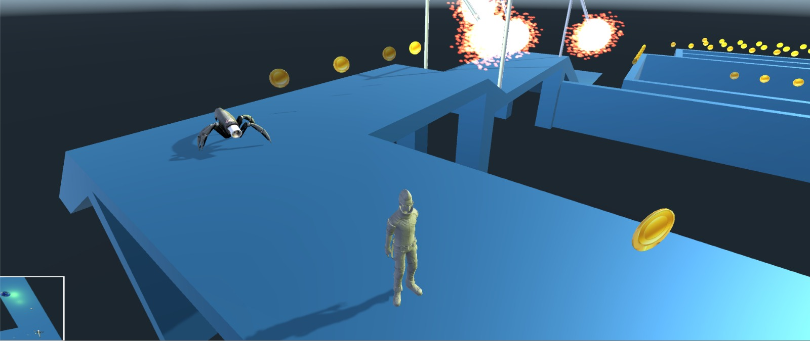

Stuck in space

Nadav Avisrur

Lidor Rosencovice

|  |  |
| --- | --- |
|  |  |

2



**INDEX**



|  |  |
| --- | --- |
| Game Overview | | p.3 |
| + Game Story | | p.3 |
| Game Screenshots | | p.4 |
| + The Map | | p.4 |
| + The Minigames | | p.5 |
| Game World | | p.6 |
| + Ethan | | p.6 |
| + Aliens | | p.6 |
| + Pendulum | | p.7 |
| + Coins | | p.7 |
| + Food | | p.7 |
| + Portals | | p.8 |
| + Checkpoints | | p.8 |
| Core Gameplay Controls | | p.9 |



OVERVIEW

3

Stuck in space is a game centered around space exploration. The level is set around the mystical galaxy called ‘Fabula’. Ethan is the only astronaut who survived his crew spaceship crash . Ethan is trying to survive and collect coins that would help him escape the planet through a teleporter back to earth. Along the way he needs to survive some obstacles and aliens that shoot bullets.

Ethan can choose with how many of these rare coins to return to earth, and he can earn them with collecting them on the map or go into some mini games that could earn him some extra coins.

Game screenshots

4

**The Map**

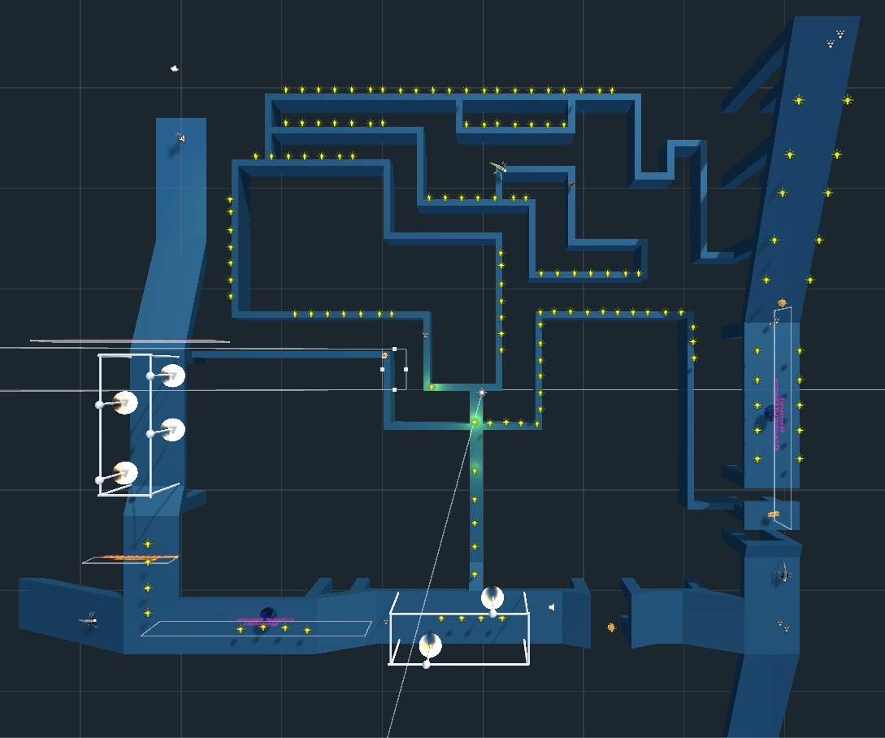

**BreakOut Minigame**

**Catch Game Minigame**

**Alien**

**Alien**

**Alien**

**Portal To Earth**

**Start**

**The Minigames**

5

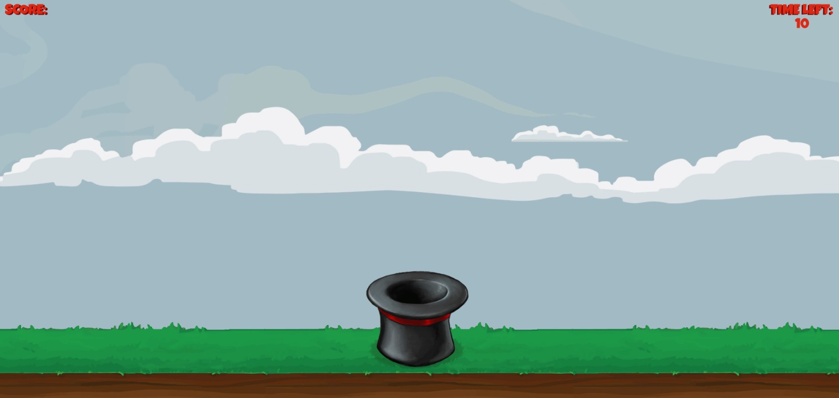**Catch Game**

**The Catch Game is a 2d minigame where Ethan can earn extra points during is exploration in the planet.**

**You need to earn coins that fall from the sky, but watch out from those bombs.**

**Coins = 50 points, Bomb = -100 points.**

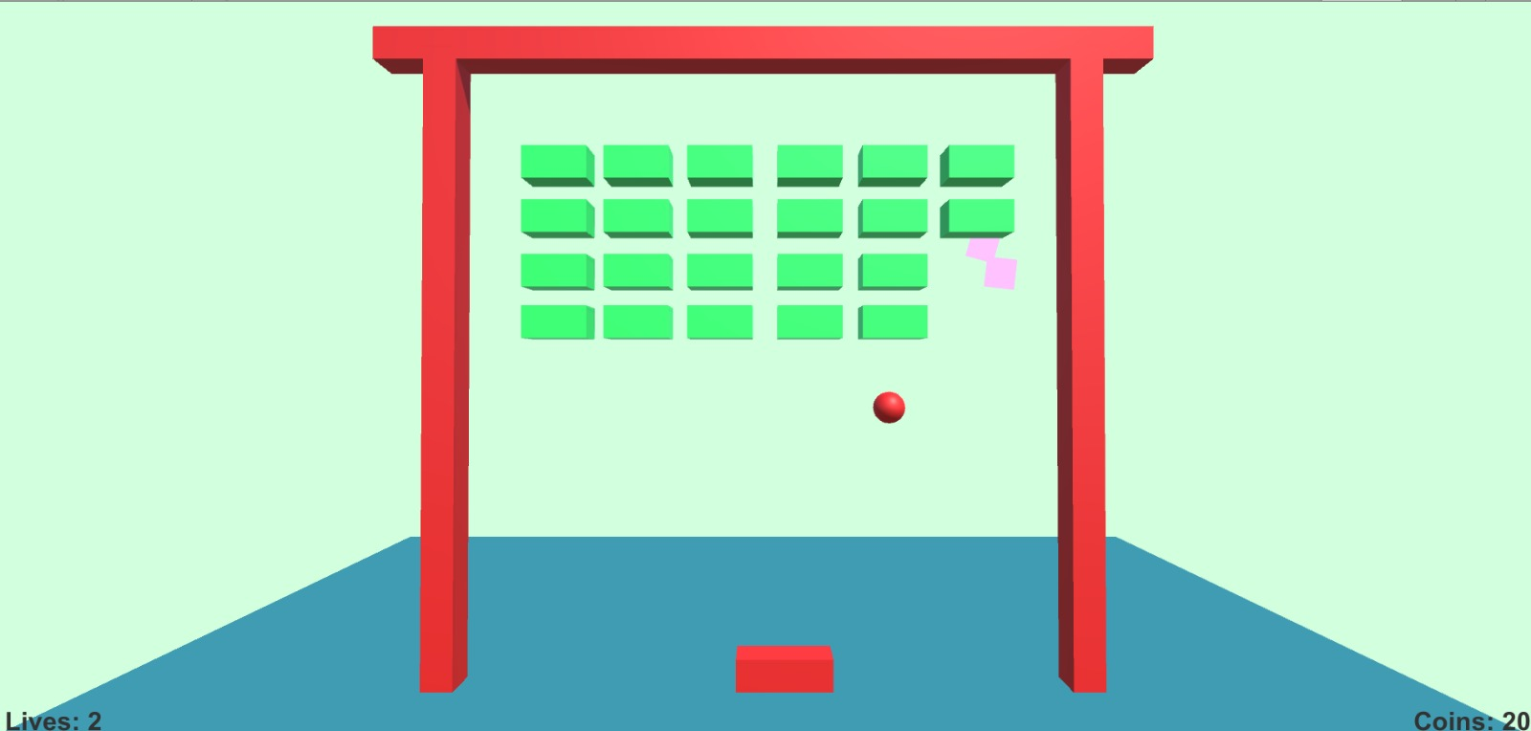**Breakout Game**

**The Breakout Game is another minigame where Ethan can earn extra coins.**

**Each brick you break, you earn 10 points, but you’ll only get 3 chances to break them all.**

Game World

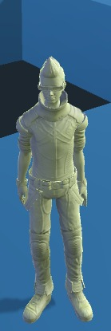

6

**Our Hero – Ethan.**

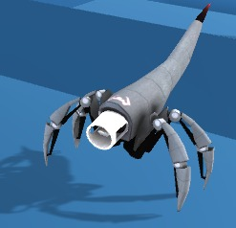

**The Aliens on the planet, they would chase you around when you get near them and shoot you which would damage you by 10 life points.**

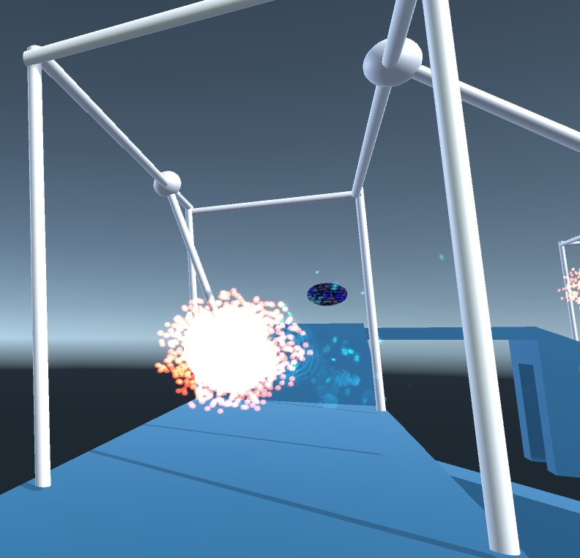

7

**The Pendulum would damage you by 10 life points.**

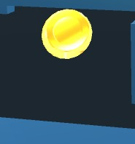

**The coins are the rare gold that Ethan need to collect before he goes back to Earth, they worth are 50 points.**

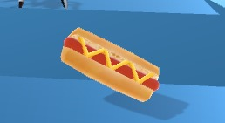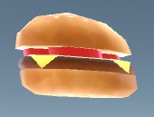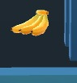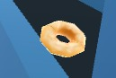

**Ethan can regain health by eating the food that he’s collecting, they gain you extra 10 life points.**

8

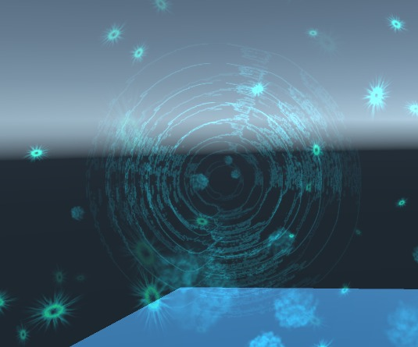

8

**Checkpoints mark the player’s respawn position whenever he dies.**

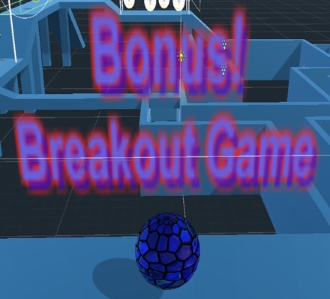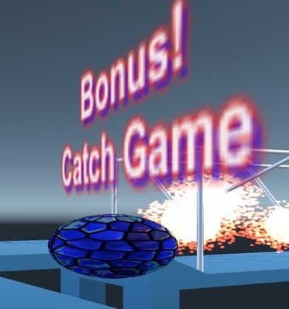

**Minigame portals, Catch Game and Breakout.**

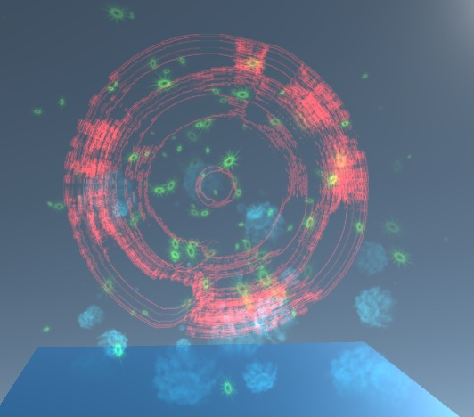

**Back to Earth portal, when steps in, game is finished with your collected points.**

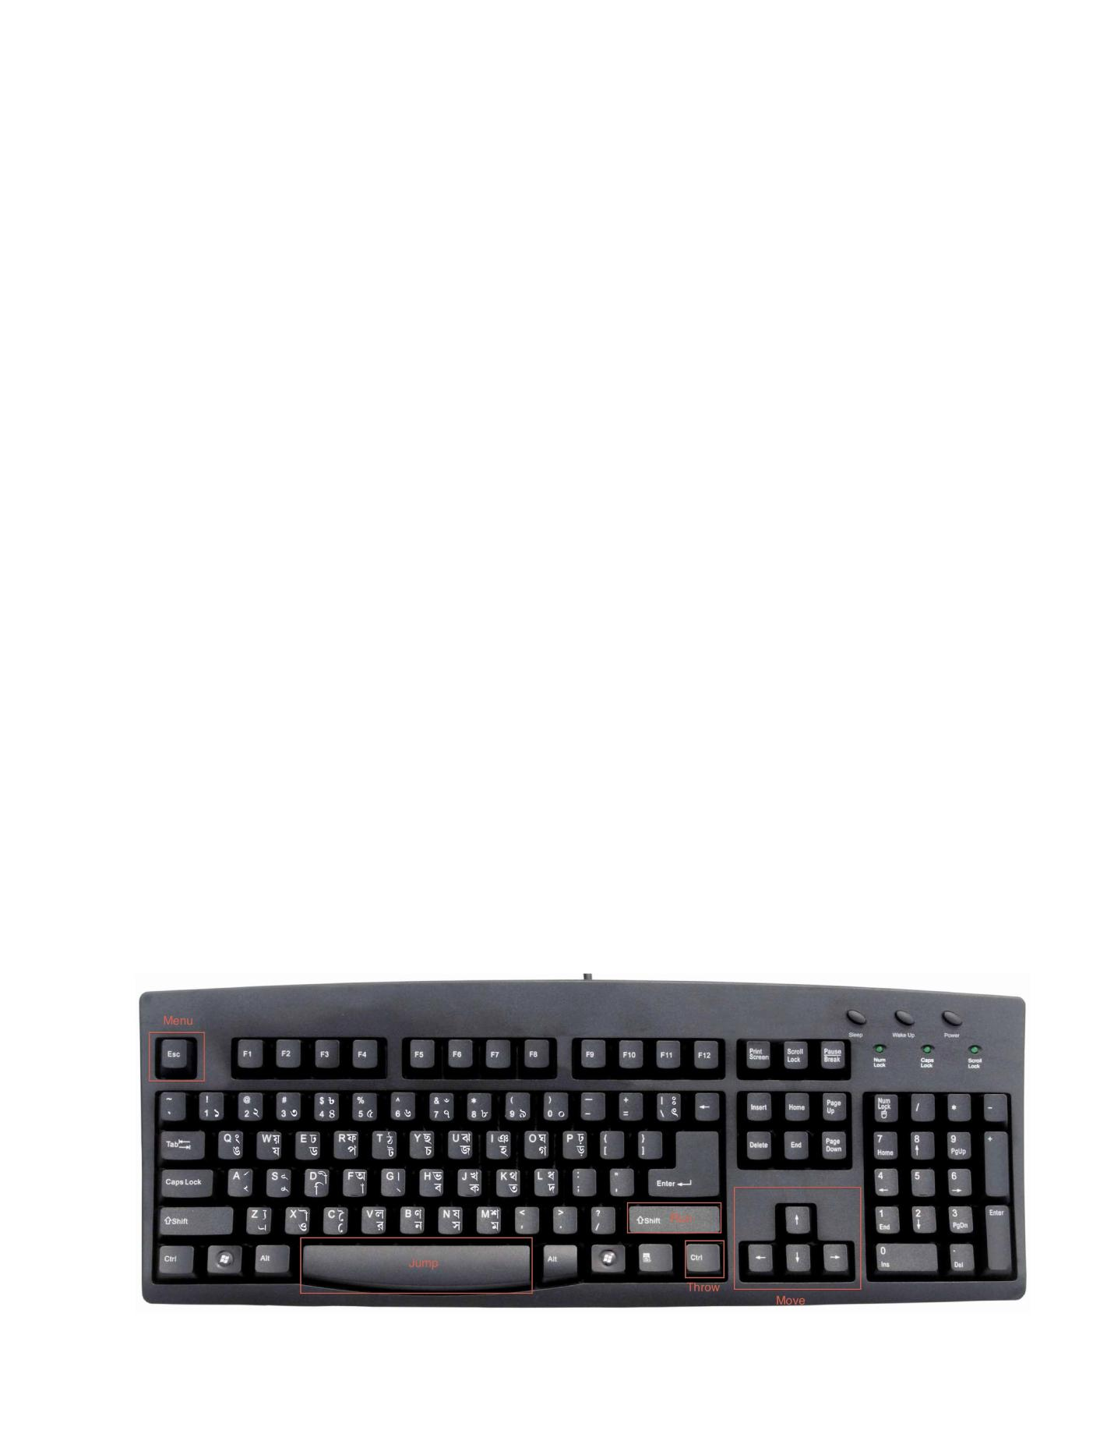

9

Core Gameplay Controls

Player Character Abilities

* Run
* Jump
* Turbo Run
* Throw Cakes at Kenny
* Curse the chef Enemy Character Abilities
* Throw food

|  |  |
| --- | --- |
| Player Action | Keyboard |
|  |  |
| Run | Arrows |
|  |  |
| Walk | Shift + Arrows |
|  |  |
| Jump | Spacebar |
|  |  |
| Menu | Escape |
|  |  |